A.L.I.V.E
Awakening Life’s Intuition &
Vibrational Energies

A journey of self awareness discovery
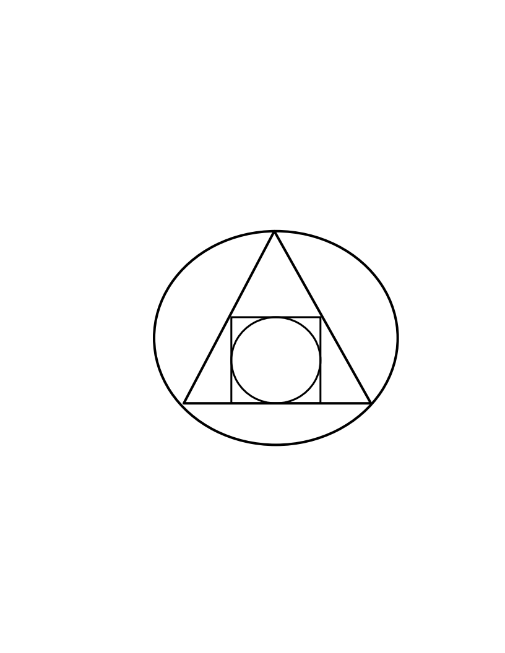

Welcome to an awareness that you may, or may not, have known to even exist, yourself.
All you need is an open mind and an overwhelming urge from deep inside.

Somewhere, Deep in your memory,
you know the Ancient ways.
This is why you find yourself drawn
by a deep seeded urge.
An urge so powerful that you don’t
even question it or fight it…..

You long for it.

For as long as human’s have been consciously aware, they have always asked certain questions. These questions, which many great Poet’s, Philosopher’s, Theorists, Scientists, and many other’s have all tried to answer, have, come up with theories, idea’s and beliefs.

- What is the meaning of life?
- What is the purpose of existence?
- What is the origin of the universe?, of Divinity?
- Who am I?

These are but a few of many questions that have been asked, and if you believe, answered, either by Spiritually, Religion, Science or a basic faith of a higher power.

A.L.I.V.E program does not answer any of these questions. It is meant to inspire self awareness development of a more intuitively inspiring nature, one that will help you awaken the Ancient ways. This is when the answers are found.

There is so much more going on around us that most never know about. The ALIVE course is an introduction into the metaphysical aspects of life and being.

To expand consciousness so that we are conscious of our unconscious.

The process of integrating the unconsciousness complexes into the conscious awareness has been around for a very long time.

Magnum Opus, or the squared circle, in Alchemy terms, or the Philosopher’s stone, is a symbol that represents the interplay of the four elements of matter, resulting in
“The great work”.

The Great work, being that which we do for our own transmutation. (Many believe that most alchemists were only looking for the ingredients to the philosopher’s stone to be able to transmute matter….Lead into gold, copper into silver.) The Great work, is in fact, what signifies the work we do for ourselves on the spiritual path of self-transcendence.

There are many ways for self-transmutation and transcendence, there is no “right way” or “only way”. It is a very unique experience for the individual. This course is to open the awareness of abundance, eternity and infinity.

There are many out there that already know, intuitively, that there is more to life than what they are living. I am hopeful that this course will help guide them to expand this awareness. I am also hopeful, that this course will inspire others to want to experience life in it’s fullness.

There are 3 main aspects to this course, Mental, Physical and Spiritual. The Mental works with the awareness of our own mind, Thoughts, opinions, emotions, EGO. The Physical is an awareness of our physical and astral body, and the spiritual is the engaged awareness of our own personal energies, consciousness and connection to all around us.

The next couple of pages, we start on the Mental. The best way to do this I find is by asking ourselves questions and really being honest with ourselves.

AWAKENING- *The act of becoming suddenly aware of something.*

What is it?

What does it mean?

When does it happen?

How does it happen?

What does it feel like?

Am I aware of awakening when it happens?

Do I stop and think about it?

You have to start becoming aware of your own questions and answers, how they feel, Intuitively.

*(Oxford English Dictionary)*
LIFE- *The existence of an individual human being or an animal.*

What is life?

What is life to me?

-Physically/Materialistic?

-Mental?

-Emotional/EGO?

What is awakening my life?

What does awakening my life mean?

You have to start becoming aware of your own questions and answers, how they feel, Intuitively.

*(Oxford English Dictionary)*

INTUITION- * The ability to understand or know something immediately without conscious reasoning*

What is it to me?

-Physically?

-Mentally?

-Emotionally/EGO?

How do I know what intuition is?

Have I ever had an Intuitive thought?

How does it feel?

You have to start becoming aware of your own questions and answers, how they feel, Intuitively.

*(Oxford English Dictionary)*

VIBRATION / VIBRATE- *To move with small movements rapidly to and fro.*

What is Vibration to me?

What makes me vibrate?

If I feel like I am vibrating, how do I feel it?

-Physically?

-Mentally?

-Emotionally/EGO?

If I feel like I am vibrating, why?

You have to start becoming aware of your own questions and answers, how they feel, Intuitively.

*(Oxford English Dictionary)*

ENERGY- *(1.)The strength and vitality required to keep active.
(2.) A Persons physical and mental powers

*Energize- To give energy and enthusiasm to
*Energetic- Sharing or involving great energy
*The capacity of matter or radiation to perform work

What is energy to me?

-Physical?

-Mental?

-Emotional/ EGO?

How does it feel?

Do I like it?
Yes? Why?

NO? Why?

You have to start becoming aware of your own questions and answers, how they feel, Intuitively.

*(Oxford English Dictionary)*
AWARENESS- *Having knowledge of a situation or fact

SELF- *(1.) A persons essential being that distinguishes them from others.
(2.) A persons particular nature or personality.

SELF-AWARENESS- * Conscious knowledge of ones own character, feeling, etc.

How do I become more self aware?

Why do I want / need to be more self aware?

Will it benefit me to become more self aware?

Why do I think / feel this way?

You have to start becoming aware of your own questions and answers, how they feel, Intuitively.

*(Oxford English Dictionary)*

TABULA RASA

We come into this world with a clean slate.
We must learn and experience to gain a better understanding and insight of our existence.

Mindful Awareness

Many of us go through life, surviving from one day to the next. Much of what we do is a focus on how to make it to the next day. We learn, grow, experience each and every day. It is human nature. Socrates said “It is human nature, the desire for knowledge.” What I would like to try and do, offer and to suggest, is that we look at and search for the meaning of our own desire for knowledge. What I mean by that, is to focus your mind, bring into your awareness of the knowledge that you know, how you got it, where you got it from, were you told to learn it? Or was it part of your own human naturalistic desire to learn what you know?

- We learn and experience every conscious moment of our physical life.
- We learn and experience every unconscious moment of our physical life.
- We learn and experience every sub-conscious moment of our physical life.

Have you ever thought of that?
Our conscious learning is when we are mindfully aware of wanting to learn a specific area of interest. Eg; a new language, driving a car, woodworking, Philosophy, etc.
Or, it could be the need to learn determined by some thing or some one other than your self. Eg; Learning a subject topic to pass a grade, learning a new technique or procedure to get promoted at work, etc

Every time and every thing we learn, creates a new experience that we unconsciously learn, and sub-consciously integrate into our thought process. This continuously upgrades our mental capacities that subtly changes our perceptions and over time, shifts our behaviors and personalities. Have you ever heard some one saying how a person has changed? Have you ever thought about your own changes? Why they occurred? Who you are today compared to before?

To mindfully, with intentional awareness, begin to explore and discover the question of “Who I Am”, “Who Am I?” and “What is my purpose?”
We start with simple questions. The following pages are to inspire thought, to bring thought into awareness of mindful thinking of thought. We have 60,000-70,000 thoughts every day, can you be mindful of each one? Of course not! But, can you imagine if you were to become mindfully aware of your relevant thoughts that increase your quality of life on a higher consciousness level, would there not be less thoughts that decrease your quality of life? Eg; Worry, Stress, Anxieties, depression, self doubt, Fear.

Mindful Sentence Completion Intervention

Notes on this Intervention:

A key to making this mindful psychology practice effective is to limit the amount of time spent in the activity. I'd recommend spending no more that three (3) minutes each morning in the sentence completion exercise. Also don't analyze your thought as you are writing - just write quickly and from a place of openness to whatever comes out.

Writing sentence stem completions quickly allows you to bypass your conscious critical mind and rely more on the answers already contained in your subconscious.

General Understanding:

The Sentence Completion intervention begins with incomplete sentences "the stem" and then has you complete the stem with (3-5) three to five different endings with the condition that the each ending grammatically completes the stem in order to form a complete sentence.

Directions

This intervention is split into three blocks of five days each. Each morning over the next 15 days write 3-5 completions for the sentence stems within each five day block.

At the end of the day, quickly review your morning sentence stems to see if you had any awareness of them through out the day. Write them down and any experience.

At the end of the five days of writing responses to the provided stems, and before beginning the next block, reread your written responses and complete the following sentence with three to five additional responses.

Block 1 (Days 1-5)

Day 1:
"If I were 10% more mindfully aware. . .
1.
2.
3.
4.
5.

"If I lived this day with 10% more authenticity . . .
1.
2.
3.
4.
5.

"If I practice listening to what my emotions are telling me . . .
1.
2.
3.
4.
5.

At the end of the day, take some time to reflect on, if any, awareness of any of the above statements became apparent at any time during the day.
End of Day Notes:

Day 2:

"If I were 10% more mindfully aware . . .

1.
2.
3.
4.
5.

"If I lived this day with 10% more authenticity. . .

1.
2.
3.
4.
5.

"If I practice listening to what my emotions are telling me . . .

1.
2.
3.
4.
5.

At the end of the day, take some time to reflect on, if any, awareness of any of the above statements became apparent at any time during the day.
End of Day Notes:

Day 3:

"If I were 10% more mindfully aware . . .

1.
2.
3.
4.
5.

"If I lived this day with 10% more authenticity. . .

1.
2.
3.
4.
5.

"If I practice listening to what my emotions are telling me . . .
1.
2.
3.
4.
5.

At the end of the day, take some time to reflect on, if any, awareness of any of the above statements became apparent at any time during the day.
End of Day Notes:

Day 4:

"If I were 10% more mindfully aware . . .

1.
2.
3.
4.
5.

"If I lived this day with 10% more authenticity. . .

1.
2.
3.
4.
5.

"If I practice listening to what my emotions are telling me . . .

1.
2.
3.
4.
5.

At the end of the day, take some time to reflect on, if any, awareness of any of the above statements became apparent at any time during the day.
End of Day Notes:

Day 5:

"If I were 10% more mindfully aware . . .

1.
2.
3.
4.
5.

"If I lived this day with 10% more authenticity. . .

1.
2.
3.
4.
5.

"If I practice listening to what my emotions are telling me . . .

1.
2.
3.
4.
5.

At the end of the day, take some time to reflect on, if any, awareness of any of the above statements became apparent at any time during the day.
End of Day Notes:

Reflection Sentence Prompt

Prior to moving to the second block pause and reread your written responses. Then complete the following sentence with three to five additional responses.

"If even some of the responses written during this 5-day block are accurate, it would serve me well to...
1.
2.
3.
4.
5.

Based on the Reflection Sentence Prompt these are the actions I will take:
(write as many actions that you can think of that will help you be mindful)
-
-
-
-
-

Block 2 (Days 6-10)

Day 6:

"If I am more accepting of my faults . . .
1.
2.
3.
4.
5.

"If I am more accepting of my fears . . .
1.
2.
3.
4.
5.

"By bringing 10% more awareness to my self-care needs . . .
1.
2.
3.
4.
5.

At the end of the day, take some time to reflect on, if any, awareness of any of the above statements became apparent at any time during the day.
End of Day Notes:

Day 7:

"If I am more accepting of my faults . . .
1.
2.
3.
4.
5.

"If I am more accepting of my fears . . .
1.
2.
3.
4.
5.

"By bringing 10% more awareness to my self-care needs . . .
1.
2.
3.
4.
5.

At the end of the day, take some time to reflect on, if any, awareness of any of the above statements became apparent at any time during the day.
End of Day Notes:

Day 8:

"If I am more accepting of my faults . . .
1.
2.
3.
4.
5.

"If I am more accepting of my fears . . .
1.
2.
3.
4.
5.

"By bringing 10% more awareness to my self-care needs . . .
1.
2.
3.
4.
5.

At the end of the day, take some time to reflect on, if any, awareness of any of the above statements became apparent at any time during the day.
End of Day Notes:

Day 9:

"If I am more accepting of my faults . . .
1.
2.
3.
4.
5.

"If I am more accepting of my fears . . .
1.
2.
3.
4.
5.

"By bringing 10% more awareness to my self-care needs . . .
1.
2.
3.
4.
5.

At the end of the day, take some time to reflect on, if any, awareness of any of the above statements became apparent at any time during the day.
End of Day Notes:

Day 10:

"If I am more accepting of my faults . . .
1.
2.
3.
4.
5.

"If I am more accepting of my fears . . .
1.
2.
3.
4.
5.

"If I bring 10% more awareness to my self-care needs . . .
1.
2.
3.
4.
5.

At the end of the day, take some time to reflect on, if any, awareness of any of the above statements became apparent at any time during the day.
End of Day Notes:

Reflection Sentence Prompt

Prior to moving to the second block pause and reread your written responses. Then complete the following sentence with three to five additional responses.

"If even some of the responses written during this 5-day block are accurate, it would serve me well to...
1.
2.
3.
4.
5.

Based on the Reflection Sentence Prompt these are the actions I will take:
(write as many actions that you can think of that will help you be mindful)
-
-
-
-
-

Block 3 (Days 11-15)

Day 11:

"To guide myself most effectively . . .
1.
2.
3.
4.
5.

" To be the best that I can be . . .
1.
2.
3.
4.
5.

“To attract more energy to myself . . .
1.
2.
3.
4.
5.

At the end of the day, take some time to reflect on, if any, awareness of any of the above statements became apparent at any time during the day.
End of Day Notes:

Day 12:

"To guide myself most effectively . . .
1.
2.
3.
4.
5.

" To be the best that I can be . . .
1.
2.
3.
4.
5.

“To attract more energy to myself . . .
1.
2.
3.
4.
5.

At the end of the day, take some time to reflect on, if any, awareness of any of the above statements became apparent at any time during the day.
End of Day Notes:

Day 13:

"To guide myself most effectively . . .
1.
2.
3.
4.
5.

" To be the best that I can be . . .
1.
2.
3.
4.
5.

“To attract more energy to myself . . .
1.
2.
3.
4.
5.

At the end of the day, take some time to reflect on, if any, awareness of any of the above statements became apparent at any time during the day.
End of Day Notes:

Day 14:

"To guide myself most effectively . . .
1.
2.
3.
4.
5.

" To be the best that I can be . . .
1.
2.
3.
4.
5.

“To attract more energy to myself . . .
1.
2.
3.
4.
5.

At the end of the day, take some time to reflect on, if any, awareness of any of the above statements became apparent at any time during the day.
End of Day Notes:

Day 15:

"To guide myself most effectively . . .
1.
2.
3.
4.
5.

" To be the best that I can be . . .
1.
2.
3.
4.
5.

To attract more energy to myself. . .
1.
2.
3.
4.
5.

At the end of the day, take some time to reflect on, if any, awareness of any of the above statements became apparent at any time during the day.
End of Day Notes:

Reflection Sentence Prompt

Prior to moving to the second block pause and reread your written responses. Then complete the following sentence with three to five additional responses.

"If even some of the responses written during this 5-day block are accurate, it would serve me well to...
1.
2.
3.
4.
5.

Based on the Reflection Sentence Prompt these are the actions I will take:
(write as many actions that you can think of that will help you be mindful)
-
-
-
-
-

Mindfulness & Awareness

Mindfulness.

Being aware of our thoughts, actions, body sensations or motivations and also of what is happening around us.

Jon Kabat-Zinn – Mindfulness author defines it as:

“Mindfulness means paying attention in a particular way, on purpose, in the present moment and non-judgmentally.”

There are many different definitions and perceptions of mindfulness. It is up to us to understand what mindfulness means to ourselves, since if the explanation or practice of mindfulness does not resonate with our own inner self, we will not really become mindfully aware of our true authentic self.

The process of mindful thought does take time and practice, it is not easy. With proper training, guidance and support, it will become a natural ability that will show you, your path more clearly on your journey of life.

Learning to understand and control your mind, is what mindfulness, in a sense does. By gaining a deeper insight into the expansive knowledge that we house in our minds, intuition, we are then able to confidently grasp the meaning of that which made no sense before. Reason without reason.

Mindfulness is active thought, It creates an awareness, but, you can be aware with out being mindful. To practice mindful awareness is when an awareness becomes a thinking thought. When we think about thought is when we are mindful, and only when we are aware of thought can we think and be mindful about it.

Awareness is when we notice, when we are conscious of, or simply, when we are aware. It usually is from one of our senses, sight, hearing, touch, taste and smell. When we start being mindful of our awareness, we then begin to develop our awareness of intuition. Meaning, we can not always explain why we know, or why it feels right, or our gut instincts, but we notice it more, trust in it and confidently start living our life by it. As perceptions start shifting with the ongoing mindful and awareness practices, the realization that several different forms of awareness consume our thoughts and drain our energy every minute, everyday. These forms of awareness distract us from our intentional mindfulness of self and create in our minds false perceptions that add, possibly, to the already misguided opinions and disconnectedness of self, blinding us from our true authentic reality. The “going ons” in everyday life are what we need to be aware of.

Awareness of the “going ons” around us does not make us mindful, it in fact creates more distractions, dilluting the thought process of mindful awareness. The “going ons” around us is everything that we focus our attention, are aware of, that really has no meaning or purpose for our own self growth and developing Mindfulness. Some examples of the “going ons” are The sports game (hockey, golf, basketball, baseball, etc.) Politics, Movies, Binging netflix, Facebook, Instagram, Or any social network Platform, What Carol said to Sue, What the new building is, The clothes that person is wearing, Work, The job, X-box or Playstation games, the cell phone, etc. The “going ons” overwhelm us, they preoccupy our consciousness and unconscious thoughts, making it almost impossible, for us, to really know if we are in fact who we really are.

To often, distraction by what is going on in the world is negative, fearful and energy sucking. This creates unpleasant memories of past events or worry thoughts about possible future events. In turn, creating thoughts that cause distress and prevent us from actively living our life. Mindfulness teaches us how to live in the now, for ourselves, without judgment, and whenever our thoughts wander, how to focus back into the present moment.

Practicing a moment by moment awareness of thoughts, feelings and sensations, we become more mindful of true self, of our energy and hidden potential that we may not have been aware of before. There are many different ways to practice mindfulness, finding the way or ways that best fit is part of the journey. As we grow and develop, changing our perceptions of self will require us to upgrade our mindful awareness practices.

We can organize mindfulness into a various amount of categories. There are 3 main categories that need to be focused on continually for mindful Self-Awareness growth and development.

Mindfulness of thought: (Mental) An awareness of thought that provides a more precise insight of how it affects perceptions, emotions, energy and possible responses and actions. Thinking of thought allows an opportunity to comprehend ones past opinions, judgments and actions. It creates a more receptive understanding of the knowledge that is accessible to make a more self aware decision in the present moment. Thus, giving a foresight of infinite cause and effect scenarios conceived of by thought.

Mindfulness of Movement: (Physical) A unique experience when awareness of sensations of physical body moving. The act of thinking thought of movement and seeing result.

Mindfulness of Energy Source: (Spiritual) Awareness of our true potential energy, A conscious awareness of energy through our energy center’s. Chakra’s . Whole aetheric, physical body sense of source energy.

Awareness

Awareness is the knowing that what is happening now, in the present moment. Internal and external. Thoughts and actions of self, Thoughts and actions of others, and, when developed, thoughts and actions self energies and of those external.

Practicing mindfulness is a discovery of self. This discovery of self can be called awareness of self. Awareness is when we recognize the “Going ons” that are part of life, that have an effect on our thought, this is when we recognize the product of our mindfulness. Awareness and mindfulness go together, when we become mindful, we are more aware, when we are more aware, the more mindful. It is what begins our journey of self discovery, growth and development.

Awareness of being aware, when this happens, it is an “AH-HA” moment, mentioned in a few other readings I have come across over the years. Consciously being aware of a particular state of mind, being able to mindfully access and decipher that which we are having thoughts about, at this time, is the ultimate goal of mindful awareness. Being aware of self thoughts, being mindful of how those thoughts cause initial responses, and being able to control the effect of those responses is just a part of mindful awareness. In essence we then can control and manipulate our reality, but, only when we become aware of true authentic self, our reality and our purpose. Which we discover on our journey within.

Unsatisfying, Frustrating, annoying, is what I think of life before awareness, yet, even still, because of awareness life is still full of frustrating and annoying moments. I can not say unsatisfying as much anymore, because with awareness comes mindfulness, with mindfulness comes more awareness, creating the amazing sensation of infinite knowledge found within. The two working together to bring acceptance of living situations as they are. Frustrating and annoying, the cause of knowing and not being able to grasp the significant meaning of knowledge buried deep inside memory, just outside of conscious understanding, yet lurking, tantalizing in the shades of past, present and future.

The preceding question pages, ALIVE and the mindful sentence completion are meant to get the mind working, inspiring new thoughts and questions that you may or may not have thought of before. This is like a warm up routine for the mind, before we get started into the heavy lifting and cardio workout. Like mentioned before, exploring and discovering one self is not a simple task. It requires determination and perseverance, a desire and a longing to get to know yourself.

Now, before we go any farther I would like to clarify what I mean when I say “Know yourself” or when thinking of self, the proper question being “Do I really know myself? How do I know that my thoughts and emotions are mine and not those of others that have influenced my growth and development of knowledge and morals. You may be thinking at this time “Of course I know myself!! What kind of BS is this guy trying to sell me?”

You can read further on in the Introduction of A.L.I.V.E course to determine whether I am the part that teaches what I believe, or the part that inspires thoughts unlocking knowledge of Atman, essence of self.

The following pages are now where we begin to really look at what and who we believe we are, why we are, and how we became who we are. We now begin to look at our self's, using an introspectively and intuitive process.

Thoughts and emotions have everything to do with who we are, and how we got here. We have to know our thoughts, understand and recognize our thoughts, when we are having thoughts and what thoughts are being created from thoughts we have had, are having and will have. The further we get into the ALIVE course, the more philosophically attuned we will get to the fundamentals of our own nature. This does take time, are you a philosophical person?

The next couple of exercises, will, in an attempt, get your your mentality aligned with your intuition on a very subtle level of your consciousness. A basic training on increased, conscious awareness of thought.

***Now, again, before we go any further, I must insist that you really think hard about what you are getting yourself into. This is a life long course, this course will become one of your addictions. Over time your thoughts will merge, Conscious into sub-conscious. Knowledge and wisdom, only a thought away. If you get tired of it, fed up with it, overwhelmed with it, scared of it, or a loss of belief with what you have discovered about yourself along the way, you can always put this course on the shelf. You can come back any time your thoughts bring you back. The awareness that you may come across, may be uncomfortable at first. The thoughts, their reasoning and emotive behaviors all will be a new sensation and experience for you. Take it slow and if you need a break, take it. If you need to talk or ask questions, ask.

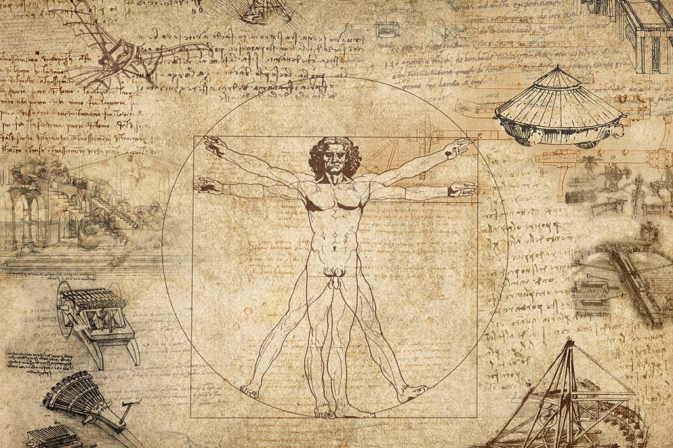
Vitruvian Man

~Leonardo Da Vinvi

Through the work of becoming mindful and aware, our thoughts and emotions are just the beginning. If we think about it, mindfulness is created in the mind and the mind being in existence because of the physical brain. With this comes an awareness of our physical body, with this also a mindfulness of the body. Of course, from the time of our birth, we constantly become more aware of our surroundings, environment and of our physical body. Our physical bodies are what give us the ability to move, our senses of sight, sound, smell, touch, and taste. As we grow and age our awareness of our physical body and all that it is capable of, and not capable of, develops.
As we continually enhance our cognitive abilities, awareness of physical body develops to a higher level of recognition. Meaning… senses strengthen, and we are better in tune and aligned with how our bodies react to the environment(s) that we are part of.
The increased understanding of own personal thoughts and emotions through mindfulness and awareness, also increases an understanding how the body is affected by certain circumstances that it comes across. We become more mindful and aware of our physical being. There is so much to explore and discover about our physical bodies and all the sensations that it does experience and how it all merges with all other aspects of our being. In this introduction course I will only be able to bring to light and to your immediate awareness, that which many of us already know, but my hope is to inspire you to look at it from a metaphysical view.
Have you ever thought about how your body feels? If you think about it, it depends on how we treat our bodies, diet, exercise etc. I know that most of us take for granted the many different functions of the body and its internal workings. Blood circulation, air circulation, digestion, and everything else that goes with it, to the basic aspect of breathing, eye blinking, swallowing. These are normal functions of our body and when we honestly start developing a mindful awareness sense of self, this also includes an awakening of new physical sensations and a keener sense of health. With that, an automatic upgrade to a healthier body and its hidden internal workings. Remember, the mind is directly linked to the brain. When we work with our mind, mindful awareness, the mind expands and becomes healthier. This in turn influences the brain and body.
Like many others starting a health journey, there are so many options, that it can be quite overwhelming. The want/need to get healthier, not knowing where to start and following what others tell you, is the “best way”. We all must start somewhere, and I will admit, it is an uphill battle the whole way. It is only uphill, because for so long, I slide down the “hill”.
When we start any new change of self, whether it be physical, mental, or spiritual, it will change the other aspects of self, also, for the positive and healthier or negative and unhealthier.
My health journey had many twists and curves, ups and downs. I know I am not the only one. When I really started understanding my own health, is when I began hanging out with others on a similar path and talking with real people about health. Physical and mental health, they go hand in hand and cannot be separated.
From the questions in the first section, you have started to inspire your thoughts to expand beyond your known physical, engaging your mental energies and exercising your thought processes. To continue one must also engage the physical energies and learn how to integrate the two.
The physical energies are directly synchronized and linked to our physical body. Enhancing our appreciation for and understanding our bodies more thoroughly employs a more in-depth familiarity with what we before may have taken for granted, our bodies.
*I am not a dietitian nor a physical trainer*. I do recommend that if you have no idea where you are on a physical level, GO SEE YOUR DOCTOR!! Then for help with the proper diet for yourself, a nutritionist or dietitian. For physical training, a personal trainer or join an exercise group and the instructor can advise from there.
I love my health! I love feeling energized! Inspired and motivated, before, during and after any form of physical activity. This feeling increases the more awareness of self is developed.
I love motivating and inspiring others to find this feeling, this sense of love also.
Let’s get started!!

Love myself.
Expanding our conscious connection with self, brings to the immediate awareness of how we think about ourselves, see ourselves and feel about ourselves. How we feel and how we see ourselves physically, directly affects our mental and emotional state of well-being. When we do not have a healthy sense of our physical self, our mental/emotional sense of self lessens. For example, always feeling tired and fatigued, sore and stiff, out of breath, aches, and pains, puts a lot of strain on our awareness of self. We become accustomed to these feelings and senses, and they become a normal part of our daily life. This can trigger anxieties and stresses, that can eventually lead to an unhealthy relationship with self. Because we have become accustomed to feeling this way, we do not recognize the effects until a later time in life.
Love myself
Loving oneself is an important part of being who you are. It helps to motivate one to take care of themselves. The physical appearance of the body does affect how we see, feel, and think of ourselves.
Do I love myself? Have you ever asked yourself this question? Honestly? What does this mean to you? How do you know you love yourself?
Now the physical work begins. The Questions in the first section got the mind warmed up, exploring, and discovering how your mind works. To use the questions to really explore, discover and understand how you know yourself.
How you look at yourself and see yourself can really determine how you actually feel about yourself. This does motivate you on how you live your life.

Activity Questions
Look in a mirror, Look at yourself. A full-length mirror is best.
How do I look?

What do I like about my looks?

How do I feel?

**Very Important – Do not compare yourself to anyone else. This is just you!!**
We spend much of our time getting ourselves ready for the external world, how we are supposed to appear. We can have many different types of looks, for the many different environments that we are a part of. Looking in the mirror to make sure that you are presentable to the outside world, is a lot different than looking in the mirror at you, for you.
This is tough, Do I love who I see in the mirror?
We can be very judgmental on the physical appearances, we need to get past those, we are the ones who choose this form for a purpose.
What do I like about my physical appearance?

Why?

What do I dis-like like about my physical appearance?

Why?

If a could change, what would It be?
Think, this is just for you and only you. You can think about your answers for as long as you need, but don’t forget! You can write them down or just have them in your mind, whatever is best for you. You can change your answers, day to day. The more you work on yourself, the answers will change to some degree.
**You will never have to show or tell these answers to anyone else**
They are just for you.
Do not be ashamed or scared of what you think about yourself, this will help you to really start being authentic with your inner essence. Knowing oneself and how we think about ourselves is in some ways harder than knowing some one else.
Love myself
How do I love myself?

How can I love myself differently?

Love has different meanings for everybody. We love people all in different ways. Many do not think about loving themselves, many do not know how. The easiest way to start to develop your own love of self is to say it to yourself.
I Love myself
Positive Affirmations work for a start, but eventually, as you become more aware, loving yourself, becomes more than just words and actions.

I Love myself

I LOVE MYSELF
For some, it may be awkward looking in a mirror and saying that, trust me, over time, you'll catch yourself in a public restroom saying it.
We as human beings have a lot of pressure on physical aesthetics. Though nowadays, there is a lot that has changed for how we can appear. The best part is that when we work on ourselves, inside and out, a change in physical appearance, is fun, adventuresome, exciting, and can also be scary. It can be the easiest place to start, and to inspire an inner confidence in self. Changing hair styles and color. Trying new styles of clothes. To an actual physical body change of reducing fat, toning muscles and working on body posture. The latter, are more intense examples of changing physical appearance, but will also build stronger confidence and awareness of self. I LOVE MYSELF
I always wore dark colors and blue jeans and a ball cap. As I starting gaining weight in my mid to late twenties, the clothes started to get bigger and bulkier, hiding anything underneath. I fit in. But fitting in does not build or add to anyone's authenticity, if anything, it is a distraction from ourselves. Fitting in hides from our inner senses, how we feel about our self, and takes so much of our time and energy, there is no room for self care and development. As I started going to the gym, getting out for walks and eating healthier, I started losing my extra mid section fat. This along with the inner self work I was doing at the time, and the people that came into my life at this time, created a new sense of awareness of myself. I started learning about myself, exploring and discovering about myself, understanding myself, from my own inner essence of self. I started to love myself, inside and out. Don’t get me wrong, there are still areas that I want to change, change is good, as long as it is authentic and for my greater good. My outer appearance has changed a lot. I still have the dark colors and jeans, they now fit better. Along with a new wardrobe comprised of compression athletic wear and many pairs of bright, colorful leggings and shirts. This change may have been the start of my mid-life crisis, but I think not. This change inspired me to be me. This simple, but major change in just my clothing, has enhance my own awareness, and has increased my energy.

I LOVE MYSELF
Changing ones clothing style does not, and is not the only way, and is not guaranteed, to increase one’s energy or confidence. It is an add on to everything else that will be happening. A physical sense of self, an awareness of physical self increases the more we work on ourselves. Another way to really bring our focus to our physical body is to be aware of our body, and also mindful. Being mindful of our physical body starts with many of the sensations that the body feels. Hot, cold, soreness and stiffness, fatigued, dehydrated and hunger. We all have these sensations, the key is to be more aware, mindful of these sensations. Being aware of these sensations is natural, being mindful means that you are taking the awareness and thinking about it, why it is, how it makes you feel, how and if you can or want to change it.
An easy way to start being mindful of your physical sensations, Body, is to start small, and not many things at once. Go for a walk, a mindful walk. An example of a mindful walk would be to feel the wind across your skin, on your hands, arms, cheeks, forehead, neck. Being attentive of how it feels on the different areas of your body. Next, notice the movement, of your legs, arms, body, as it works in unison with itself. Feel the sensation of your feet taking their steps and every time they touch ground and lift off. Increase your speed, lengthen your steps, paying attention to how the muscles move and feel, how your breathing changes. It seems like a lot, do one at a time until it becomes habit.
The more we become aware of our deeper physical sensations, the more aware we become of our own uniquely individualistic personal energies. There is a physical aspect to our sense of self, but also, at the same time, there is an energy aspect, our aura, etheric body, our energy body.

With combining the enhanced awareness and mindfulness of our mental and physical, metaphysically speaking, we are now studying, exploring and understanding our being, our realities and existence. Which now also brings to our conscious awareness, an increased cognitive and intuitive sensitivity of our personal energy.

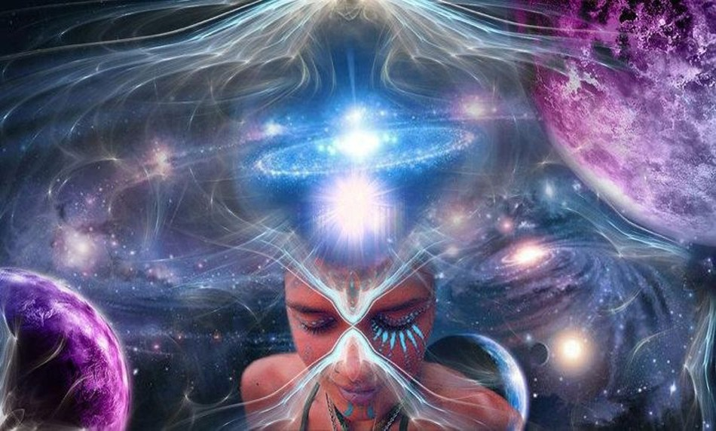

PERSONAL ENERGY

~Physical
~etheric
~Astral
~Spiritual
~Consciousness

Personal Energies

Asking ourselves questions, about ourselves, will inevitably lead us to a new, or at least, a more understanding and awareness of who we are, why we are, How we are. With this comes a more in depth feeling of our senses, a connection to our own personal energies.

Everything in the known universe is made from energy vibrating all at different frequencies. What you see, feel, hear, it’s all energy vibrating. Stone, dirt, houses, cars, animals, Plants, Humans. Everything that we can see and touch, and even that which we can not, it’s all energy vibrating on it’s own specific frequency.

Our own personal energies, are vibrations on a certain frequency. It is up to us to become aware of them, and of those around us. As said before everything vibrates on a certain frequency. Living creatures vibrate on a different frequency than non-living. All living creatures vibrate on the same frequency, but with a variance of degrees. For example, animals such as K-9 or feline, and humans, all are vibrating on the same frequency, just different degrees. The degrees of which we vibrate, determine our active consciousness. With that said, humans, while all vibrating on the same frequency or level, with each other, also vibrate on different levels and possibly, other frequency’s. The degrees of our energy are determined by our connection with consciousness. Our energy consciousness, this is what connects body, soul and spirit. Our energy consciousness is in essence our spirit, the eternal part of our existence, it is what created thought of the body we are now living in.

The higher the degree of vibration, the more energetic and positive we feel. This also determines how healthy we are in physical body and in mind but also intensifies our connection and awareness with our energy consciousness. Discovering our degree of vibration and what invigorates, increases and sustains it is the basic fundamental element of Awakening Life’s Intuition and Vibrational Energies. We are all unique, and in such, need to discover our own degree and levels of vibration.

Have you ever been really still and just felt your Energy? Your Vibration?
Let’s try it really quick.

- Step 1. Pick an area where you will not be distracted (to much).
- Step 2. Get into a comfortable position, that you can sustain for a couple of minutes. ( without you needing to fidget and reposition)
- Step 3. With your eyes open, just relax and look around, breathe easy.
- Step 4. Start sensing your body, the feeling of it. Look at your hands, if this helps. Feel the sensations, the tingling, the vibration in your fingers, working into your palms, into your forearms, up your arms and into your shoulders, chest and down through your torso into your legs, calves, into your feet and toes.
- Step 5. Feel the vibration of your body, your whole body, all at once. There is no one area that has more vibration than another. You might be more sensitive in some areas than others, but the vibration sensation is all over.
- Step 6. Close your eyes, focus on your breath. Breath in, breath out. As your breath in, feeling the sensations of the air moving into your body. As you breath out, feel the air moving out. Be still and breath
- Step 7. Feel the vibration of your body, the sensations of your energy. This is your energy, your vibration, your energy within body.
- Step 8. Push your energy out, feel it expand past your physical body and into the area surrounding. How far out from body can you sense your energy?
Hold on to that sensation.
- Step 9. Open your eyes, concentrating on your energy inside and outside the physical body. Vibrating as one, being one, inside and out, outside and in.
- Step 10. With eyes open, feel the peace and serenity with self, with universe and with existence. Sense the expanse of your energy, connecting with all that there is, energy of universe, energy of existence, source energy.
- Step 11. Look around, notice that which you saw before, still in tune with your energies. Feel your energies expanding, connecting with all that you see, reach out with your energies. Let the vibrations of your energy sense and feel the vibrations of the energies around you.
- Step 12. Be aware of your vibrational energies. Be aware of other vibrational energies.

Imagine this all the time, You Alive, Vibrating, connected.

It sounds like a form of meditation, and it is. Slightly different than what most people think about meditation, in the aspect that you can do it any where. You do not need to be sitting in a quiet corner, in your mediation area. The more you do it, the easier it becomes to do it anytime, anywhere. Standing, walking, at work, around the house, in the car, on the bus. You do not need to pick a certain time to do it, anytime you think of it, do it! This awareness of your energies will become a natural part of your every day and you will become “Tuned into it” full time. Like breathing, it will just happen.

There are many ways to become aware of our personal energies, to name a few of the most mainstream, Yoga, meditation and many other naturalistic forms of health and wellness.

There are also many ways to enhance ones energies, and or awareness of ones energies. Just to name a few, through the use of crystals, plants (essential oils, flower essences) Water and sound. (There are many more types available) All of these have their own natural energy vibration. Certain people, also can help us enhance or become aware of our energies. Energy workers, Natural paths, holistic healers and energy sensitive mediums.
The use of any external effects, possessions or people to enhance ones energies, while at first helps, needs to also be realized that they all have their own vibrational energy, which could interfere or mask our own. Meaning, many people do not believe that they can increase and enhance their own energy, coming to believe that they “need” the external assistance found in other people and crystals. This undermines ones main core power center of being and energy consciousness. A consciously active awareness of one’s energies and connection to consciousness will stimulate one’s knowledge and wisdom of their true authentic essence of self. Unlocking the barriers of the physical mind, connecting to energy consciousness of spirit. Connecting to universal energy and Source energy.

We are all connected, all the time to this energy, Source energy. Our personal energies are but just a drop of this source energy, It is what gives us life.

Even though source energy is all around us, all the time, and that our personal energies are a drop of it, we still need to have our own power source, Chakra’s. The Chakra’s are that which generate our own personal energies, our very own energy source. Have you ever wondered why we humans are always seeking new and inventive ways of creating energy? Especially, clean, renewable and infinite source of energy? We are trying to copy ourselves. Every living organism, has it’s own power source. For humans, it is the Chakra’s. There is a lot to be learned from and about the chakra’s. More that can be learned in a moment of a life time, which perhaps is why our energy consciousness is eternal.

This course is an introduction to our vibrational energies, as such, does not have the means to be able to create a master journal or full in-depth explanation about our power center. There is a vast amount of material available for one to study, and many different techniques to put it all into practice. My hope with this course, is that it helps to expand your inspiration to explore the more esoteric aspects of our being and energy.

With that, we will continue on the with very basics of our personal energies / power center / Chakra’s.

There is only one condition…. open your mind, your senses, your intuition.
There is no right way or only way, just your way. The way for someone else, can help you find your way, but another’s way will not be your way. That must be found within.

Becoming aware of and learning about your energy / power center starts with the first experience in the before mentioned meditation. Another way is attuning yourself to your energy and aligning your conscious awareness with it.

We will begin with a quick tutorial of how our power / energy center has been defined over time.

The Chakra’s.

The following diagram shows the many different areas and functions of our energy center. This is a basic representation of the colors associated with our chakra’s, and the region of the body they look after. There is much information that can found online about the chakra’s and their workings, this diagram is but one of many that I have found.

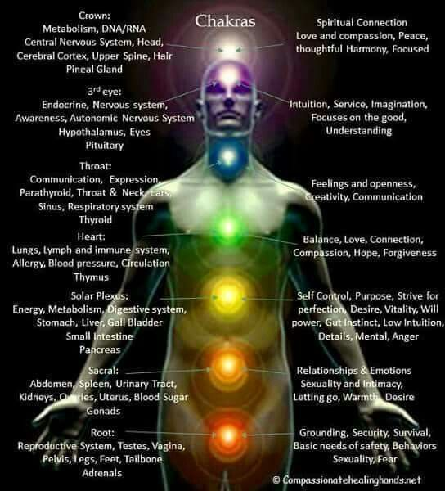

Shown above are the 7 main Chakra’s, there are many more, lesser and minor Chakra’s, and they all have a vital role in keeping our physical body, etheric/energy body, and our spiritual body healthy.

~At this time, I would like to also mention that the terms etheric, energy, astral, spiritual bodies, or any number of other ways to describe our energies in esoteric way’s, can be really confusing to try and separate and make sense of them all. It really depends the area of study that one is focusing on, will describe it a certain way. Every culture and religion has their own specific view and beliefs. This course is not meant to teach a certain way, but to bring to one’s awareness the many various ways to describe ourselves on a metaphysical level of awareness. Every term can be used to describe the same meaning, subtly different in meaning or can be very different, I would like to suggest that no matter which way you want to describe each term, the one that resonates best with the inner you, is the one that works. So do not in the beginning get caught up in the “proper” usage of terms, they are after all “Human terms” meant for us to teach our specific ways of belief. Your intuition will guide you on your path.~
There is so much available to us for learning about and experiencing our own personal energy(s), the Chakra’s, while being widely known and talked about, is a small piece of that knowledge. There are so many different beliefs and opinions that it can become overwhelmed and possibly even a burden, trying to learn it all. You do not have to learn it all! You do not need to be an expert! You be you! For our own knowledge is best attained when we learn with an interest and a passion, and wisdom is only acquired from our own personal experiences.
Our personal energy(s), are uniquely our own. The terms chakra, aura, astral, etheric, or any number of other ways to describe personal energy, are just our human way to verbally describe to another, when we are talking. There are so many ways to feel and sense this energy that at times, to verbally express to another is in no way comparable. I want to impress onto the reader, the student, the teacher, that we can spend so much time learning and studying in only one section of new knowledge that we may, in our studies of gaining new knowledge, inadvertently forget our purpose for learning. One can spend years studying and learning one area, and also that area’s branches of learning, we become experts in that field, respected and admired for what we know. But….that is not for everyone. We need experts in all area’s, for those experts are the ones that help others learn. We also need teachers and students in area’s that do not focus intently on the one, but also the many. As for personal energies, we can learn how other’s describe and experience their personal energies and belief, yet, we must always be aware and mindful of how those teachings resonate within our own Atman, inner essence.

Since an awareness of our personal energy(s) is a unique sensation and experience, when we are feeling these sensations for the first time or expanding our awareness of the possible multitude of energies that we do have, experimentation and an open mind is a necessity. Personal Energy Actuators, (PEA) can help us develop and increase our personal energy awareness and understanding.
The following is a basic list of Personal Energy Actuators:
Talking with like minded individuals, Crystals, Meditation, Physical movement (Walking, exercise, etc), Yoga, Essential oils, Flower / Plant essences, Sunlight, Moonlight / Starlight, Earth, Wind, Water, Fire, etc.
Actuators have a certain energy frequency that resonates with our own energy, adding to our energy, merging with it, and intensifying both energies to vibrate on a higher level. It is like finding the picture within the picture for the first time, you can always see it after. Actuators do the same, once you feel a certain energy vibration, it is easy to feel it again. Actuators are a great way for exploring our personal energy vibration, by helping us become aware of how our energies vibrate on each level, by each degree of conscious awareness. Selecting an actuator for a specific energy required and also one that entwines with our own energies has much to do with our experience, understanding and intuition. For example, For me, Amethyst is my birth crystal. I have always been drawn to it and loved the look and feel. (When I say feel, it is the energies emitting from the Amethyst) There are many different attributes assigned to Amethyst, one being that it helps one transmute energies from lower to higher levels, allowing for a connection to the spirit and ethereal levels. I wear an Amethyst around my neck, have for many years now. It feels right, there is always a connection. If I wear another crystal, the feeling is off. I clear this Amethyst every night in a salt bowl, since it also protects against psychic attacks. I feel when I am not wearing it, I feel when it is a different crystal. This Amethyst now is a regular part of me, I am not able to switch it out and get the same effect. Being able to understand your energy and how it “Gets along” with another is very important. It is easy for one to read about the certain qualities that a crystal, or another actuator has, it is another thing all together to find the right actuator, with the qualities you are looking for that blends seamlessly with our own. Actuators will always feel good, and be able to connect with our own energy. Your personal energy actuator (PEA), will be one that has a much stronger vibration and pull, and will have a much deeper connection with you on your energetical level. Not all actuators will have the same effect, they all feel good, and look good, and add to your energy, and the energy of your immediate environment, but there will always be those that compliment and intensify our energy on a much more intimate level of consciousness. Like a soul mate. Take your time, get to know your energy, then finding your actuators becomes natural, or they find you.
Remember, mentioned above about not believing in your own energies and using energy actuators as a full time energy source. Finding your Personal Energy Actuator(s) will be an awareness of experience only if and when you believe in yourself and your energy(s).
The transformation that one undergoes as we start working with and understanding our energies is a subtle change. It is an evolution of self. It is purpose, meaning and reason. We overwhelm ourselves everyday with so many distractions that we have slowed our evolutionary consciousness. We (Humans) all have the same fundamental purpose of being in existence, and yet, we all have our own individual purpose(s), that has its own meaning and reasons for us. We spend so much energy searching for the Purpose, the meaning and the reason for “Human” existence, when we should be exploring and discovering within ourselves. Inner exploration and understanding Awakens our Life’s Intuition and Vibrational Energies, expanding our consciousness and awareness of creation and existence.
CONCLUSION
Go within, be within, find yourself, be yourself, takes a lot of work when we are not used to it. We must also, on our journey, during the exploration and discovery of self, let our self be. Allow self the time just to be, to see the sights, hear the sounds, smell the fragrances, feel the textures and tastes the flavors. When we spend time being mindful and aware, with intention, we can miss the little things that are also happening around us, outside our intentions. Be non-judgmental in the moment, just be.
This course has promoted inspiration of thought. It has answered some questions, created many more, Sorry, not Sorry!
The continuation of your progressive journey for Purpose, meaning and reason is the outcome of this course. This course is by no means the end of your journey, only the start. Before this course, you may have felt or known that you have a specific purpose in life, we all do. Vaguely through out the course, there has been many hints about the purpose that we all share, that we are looking for, to understand. Here is a clue; We have many purposes and those have meaning, and the meaning has reasons. When we uncover the reason why it has meaning, purpose is revealed. That purpose allows us to experience a piece of what life and existence has to offer in abundance.
Again, Sorry, still vague...Not Sorry! Excited! For every purpose that we uncover, explore and understand, there will be another. Always getting us closer to the understanding and the purposeful meaning of life.

